Audio equalizer

**Peter Anton Naguib - 7406**

**Fadi Sarwat Farouk - 7432**



# Source code:

## Function to generate the numerator and denominator coefficients of a low-pass filter (FIR or IIR) based on the specified parameters.

% Function to design a low-pass filter

% Inputs:

% samplerate: Sample rate of the signal

% cutoffFreq: Cut-off frequency of the filter

% order: Order of the filter

% filter: Type of filter (FIR or IIR)

% Outputs:

% a: Coefficients of the filter's denominator polynomial

% b: Coefficients of the filter's numerator polynomial

function [a, b] = low_pass_filter(samplerate, cutoffFreq, order, filter)

% Calculate the Nyquist frequency

fm = samplerate / 2;

% Normalize the cut-off frequency

wn = cutoffFreq / fm;

if (filter == "FIR")

% Design a finite impulse response (FIR) filter using the FIR1 function

[a, b] = fir1(order, wn, 'low');

% Ensure equal length of the coefficient vectors a and b

[a, b] = eqtflength(a, b);

elseif filter == "IIR"

% Design an infinite impulse response (IIR) filter using the BUTTER function

[a, b] = butter(order, wn);

% Ensure equal length of the coefficient vectors a and b

[a, b] = eqtflength(a, b);

end

end

## Function to generate the numerator and denominator coefficients of a band-pass filter (FIR or IIR) based on the specified parameters.

function [a, b] = band_pass_filter(samplerate, cutoffFreq1, cutoffFreq2, order, filter)

% Calculate the Nyquist frequency

fm = samplerate / 2;

% Normalize the cut-off frequencies

wn = [cutoffFreq1 cutoffFreq2] / fm;

if (filter == "FIR")

% Design a finite impulse response (FIR) filter using the FIR1 function

[a, b] = fir1(order, wn, 'bandpass');

% Ensure equal length of the coefficient vectors a and b

[a, b] = eqtflength(a, b);

else

% Design an infinite impulse response (IIR) filter using the BUTTER function

[a, b] = butter(order, wn, 'bandpass');

% Ensure equal length of the coefficient vectors a and b

[a, b] = eqtflength(a, b);

end

end

## Function to apply a band-pass filter to an input signal using the numerator and denominator coefficients.

function result = apply_filter(filter_type, gains, audio_data, sample_rate)

% Define cutoff frequency ranges for each band

freq1 = [0, 170, 300, 610, 1005, 3000, 6000, 12000, 14000];

freq2 = [170, 300, 610, 1005, 3000, 6000, 12000, 14000, 20000];

filter_order=0;

% Set filter order based on filter type

if filter_type == "FIR"

filter_order = 600;

elseif filter_type== "IIR"

filter_order = 4;

end

% Apply low-pass filter to the audio data for the first band

[a, b] = low_pass_filter(sample_rate, 170, filter_order, filter_type);

filtered_data = filter(a, b, audio_data);

result = filtered_data * gains(1);

% Apply band-pass filters to the audio data for the remaining bands

for i = 2:9

[a, b] = band_pass_filter(sample_rate, freq1(i), freq2(i), filter_order, filter_type);

filtered_data = filter(a, b, audio_data);

result = result + filtered_data * gains(i);

end

end

## Function to analyze the input and output of a filter. It analyzes the impulse response, step response, magnitude and phase, and poles and zeros of the filter.

function analyze_signal = analyze_signal(samplerate, filter_type, audidata)

freq1 = [0 170 300 610 1005 3000 6000 12000 14000];

freq2 = [170 300 610 1005 3000 6000 12000 14000 20000];

num_samples = length(audidata);

fs = samplerate;

t = linspace(0, num_samples/samplerate, num_samples);

f = linspace(-fs/2, fs/2, num_samples);

if (filter_type == "FIR")

order = 600;

else

order = 8;

end

[a, b] = low_pass_filter(samplerate, 170, order, filter_type);

%get transfer function based on the ni=um and denum of low pass filter

TF = tf(a, b);

% Filter analysis

figure();

subplot(2, 1, 1);

freqz(a, b, num_samples);

title('Magnitude and phase of input low pass filter frequency (0-170)');

subplot(2, 1, 2);

pzmap(tf);

title('Poles and zeros of low pass filtered signal (0-170)');

figure();

subplot(2, 1, 1);

impulse(TF);

title('Impulse response of low pass filtered signal (0-170)');

subplot(2, 1, 2);

step(TF);

title('Step response of low pass filtered signal (0-170)');

% Output analysis

y = filter(a, b, audidata);

Y = fftshift(fft(y));

figure();

subplot(3, 1, 1);

plot(t, y);

title('Time domain of the output signal (0-170)');

subplot(3, 1, 2);

plot(f, abs(Y));

title('Magnitude of the output signal (0-170)');

subplot(3, 1, 3);

plot(f, angle(Y));

title('Phase of the output signal (0-170)');

for i = 2:9

[a, b] = band_pass_filter(samplerate, freq1(i), freq2(i), order, filter_type);

TF = tf(a, b);

% Filter analysis

figure();

subplot(2, 1, 1);

freqz(a, b, num_samples);

range = strcat(' (', int2str(freq1(i)), 'Hz - ', int2str(freq2(i)), 'Hz)');

title(strcat('Magnitude & Phase of H', int2str(i), '(Z)', range));

subplot(2, 1, 2);

pzmap(tf);

title(strcat('Poles and zeros', int2str(i), '(Z)', range));

figure();

subplot(2, 1, 1);

impulse(TF);

title(strcat('Impulse response', int2str(i), '(Z)', range));

subplot(2, 1, 2);

step(TF);

title(strcat('Step response', int2str(i), '(Z)', range));

% Output analysis

y = filter(a, b, audidata);

Y = fftshift(fft(y));

figure();

subplot(3, 1, 1);

plot(t, y);

title(strcat('Time domain of the output signal', int2str(i), '(Z)', range));

subplot(3, 1, 2);

plot(f, abs(Y));

title(strcat('Magnitude of the output signal', int2str(i), '(Z)', range))

subplot(3, 1, 3);

plot(f, angle(Y));

title(strcat('Phase of the output signal', int2str(i), '(Z)', range));

end

end

## GUI code

properties (Access = public)

filename;

pathname;

fs=0;

fs_original=0;

audio;

audio_old;

gainsArr = ones(1, 9);

end

methods (Access = private)

function apply(app)

app.audio = apply_filter(app.FilterDropDown.Value, app.gainsArr, app.audio_old, app.fs_original);

app.draw();

end

function draw(app)

plot(app.originalPlot, app.audio_old);

plot(app.enhancedPlot, app.audio);

end

end

% Callbacks that handle component events

methods (Access = private)

% Button pushed function: browseButton

function browseButtonPushed(app, event)

[file, Pathname] = uigetfile('*.wav','wav file selector');

app.filename = file;

app.pathname = strcat(file, Pathname);

[app.audio, app.fs] = audioread(file);

app.audio_old = app.audio;

app.fs_original=app.fs;

app.fileaddressEditField.Value = app.filename;

app.samplerateEditField.Value = app.fs;

app.draw();

end

% Button pushed function: play_Button

function play_ButtonPushed(app, event)

clear sound

sound(app.audio, app.fs);

end

% Button pushed function: stop_Button

function stop_ButtonPushed(app, event)

clear sound;

end

% Value changing function: HzSlider_2

function HzSlider_2ValueChanged(app, event)

value = 10^(event.Value / 20);

app.gainsArr(2) = value;

app.slider_disp_2.Text = mat2str(value, 2);

app.ApplyFiltersButton.Enable = 1;

end

% Value changing function: HzSlider

function HzSliderValueChanged(app, event)

value = 10^(event.Value / 20);

app.gainsArr(1) = value;

app.slider_disp_1.Text = mat2str(value, 2);

app.ApplyFiltersButton.Enable = 1;

end

% Value changing function: HzSlider_3

function HzSlider_3ValueChanged(app, event)

value = 10^(event.Value / 20);

app.gainsArr(3) = value;

app.slider_disp_3.Text = mat2str(value, 2);

app.ApplyFiltersButton.Enable = 1;

end

% Value changing function: HzSlider_4

function HzSlider_4ValueChanged(app, event)

value = 10^(event.Value / 20);

app.gainsArr(4) = value;

app.slider_disp_4.Text = mat2str(value, 2);

app.ApplyFiltersButton.Enable = 1;

end

% Value changing function: HzSlider_5

function HzSlider_5ValueChanged(app, event)

value = 10^(event.Value / 20);

app.gainsArr(5) = value;

app.slider_disp_5.Text = mat2str(value, 2);

app.ApplyFiltersButton.Enable = 1;

end

% Value changing function: HzSlider_6

function HzSlider_6ValueChanged(app, event)

value = 10^(event.Value / 20);

app.gainsArr(6) = value;

app.slider_disp_6.Text = mat2str(value, 2);

app.ApplyFiltersButton.Enable = 1;

end

% Value changing function: HzSlider_7

function HzSlider_7ValueChanged(app, event)

value = 10^(event.Value / 20);

app.gainsArr(7) = value;

app.slider_disp_7.Text = mat2str(value, 2);

app.ApplyFiltersButton.Enable = 1;

end

% Value changing function: HzSlider_8

function HzSlider_8ValueChanged(app, event)

value = 10^(event.Value / 20);

app.gainsArr(8) = value;

app.slider_disp_8.Text = mat2str(value, 2);

app.ApplyFiltersButton.Enable = 1;

end

% Value changing function: HzSlider_9

function HzSlider_9ValueChanged(app, event)

value = 10^(event.Value / 20);

app.gainsArr(9) = value;

app.slider_disp_9.Text = mat2str(value, 2);

app.ApplyFiltersButton.Enable = 1;

end

% Button pushed function: ApplyFiltersButton

function ApplyFiltersButtonPushed(app, event)

app.ApplyFiltersButton.Enable = 0;

app.apply(); % slow function

clear sound;

sound(app.audio, app.fs);

end

% Button pushed function: SaveButton

function SaveButtonPushed(app, event)

audiowrite('enhanced.wav', app.audio, app.fs);

end

% Value changed function: samplerateEditField

function samplerateEditFieldValueChanged2(app, event)

value = app.samplerateEditField.Value;

if value == app.fs

app.audio = app.audio_old;

elseif value > app.fs

app.audio = upsample(app.audio_old, value/app.fs);

app.fs=value;

app.apply

elseif value < app.fs

downsamplingFactor = floor(app.fs/value); % Round down to nearest integer

app.audio = downsample(app.audio_old, downsamplingFactor);

app.fs=value;

app.apply

end

app.ApplyFiltersButton.Enable = 1;

end

% Button pushed function: AnalyzeButton

function AnalyzeButtonPushed(app, event)

analyze_signal(app.fs, app.FilterDropDown.Value, app.audio);

end

% Value changed function: FilterDropDown

function FilterDropDownValueChanged(app, event)

app.ApplyFiltersButton.Enable = 1;

end

end

## Sample Runs

1. A screenshot of a computer

   Description automatically generated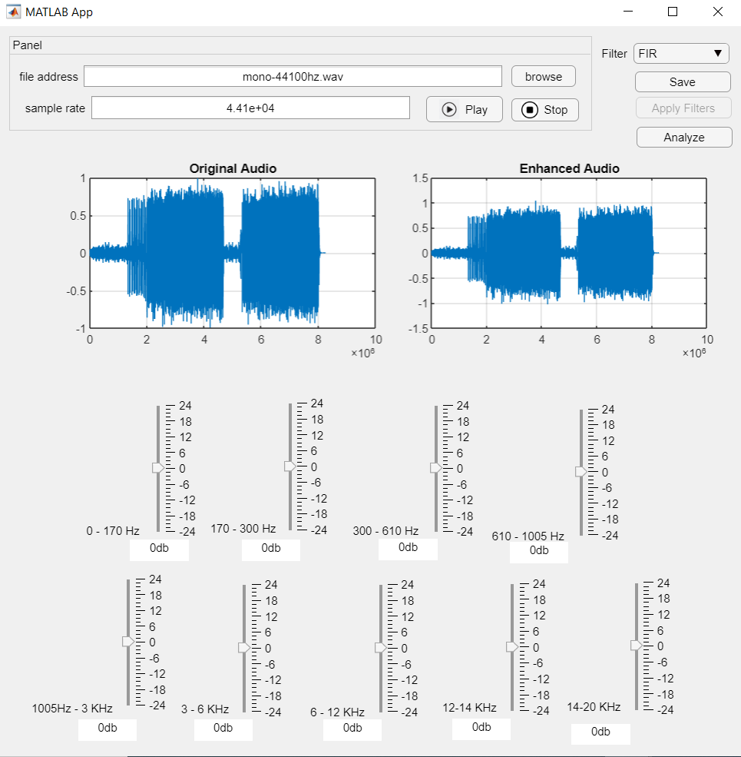Using fir filter-sample rate 44100

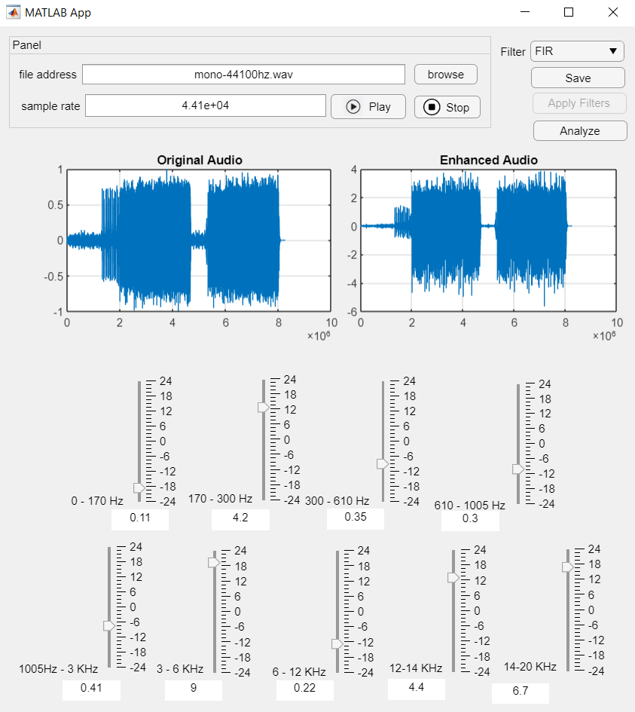

1. 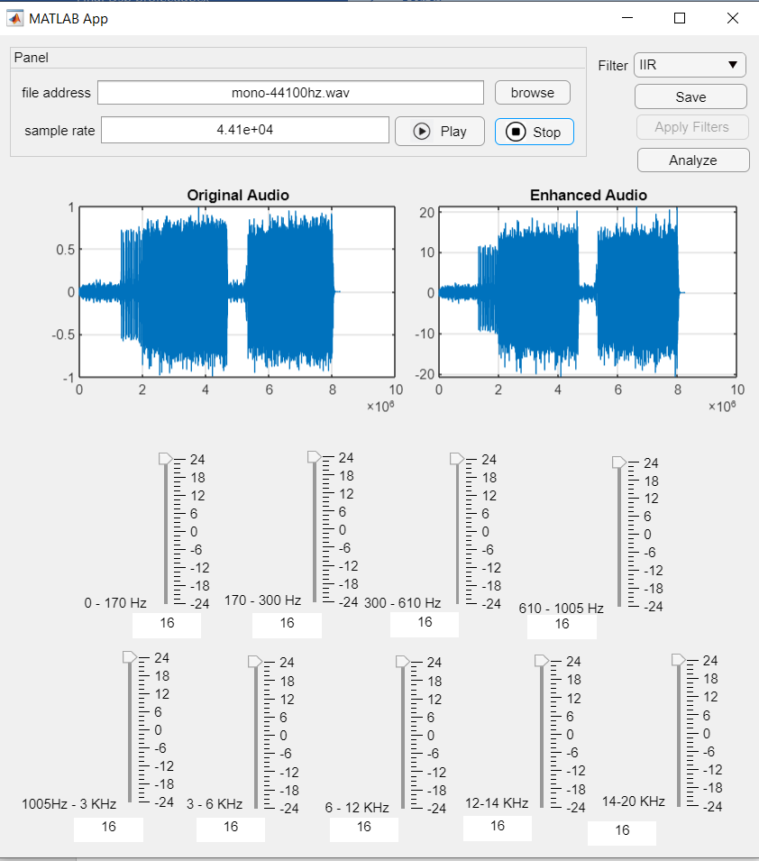**A screenshot of a computer

   Description automatically generatedA screenshot of a computer

   Description automatically generatedA screenshot of a computer

   Description automatically generated**Different gains using IIR with sample rate 44100.

## A screenshot of a computer Description automatically generatedDown Sample from 44100 to 22050

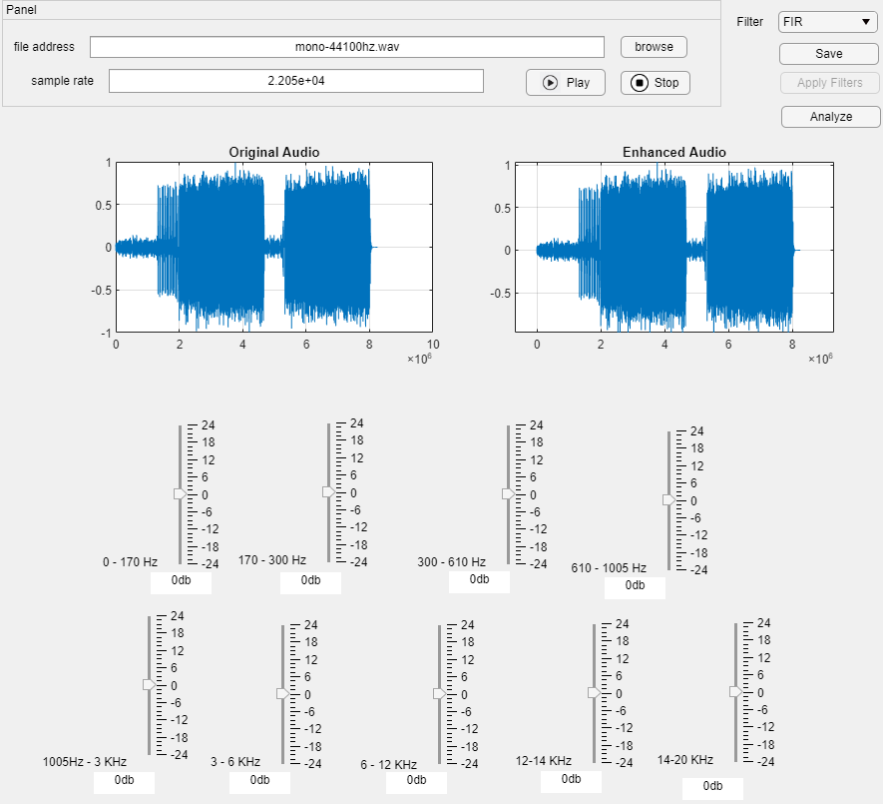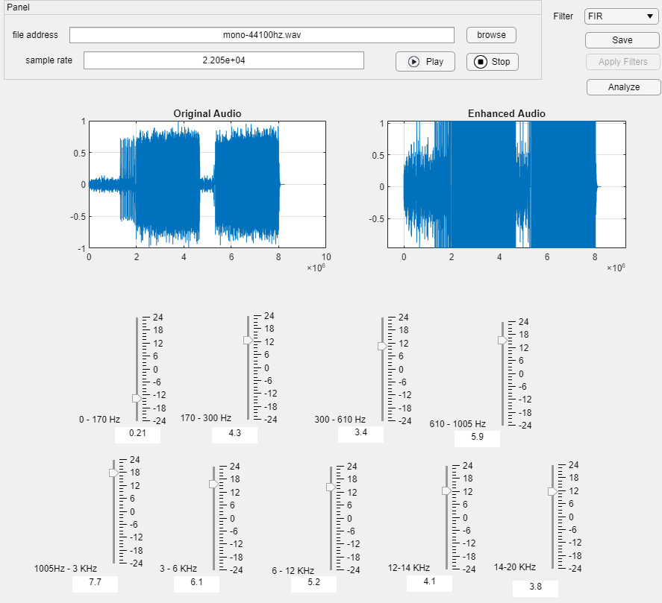

## A screenshot of a computer Description automatically generated with medium confidenceA screenshot of a computer Description automatically generatedA screenshot of a computer Description automatically generated with medium confidenceUp Sample from 44100 to 88200

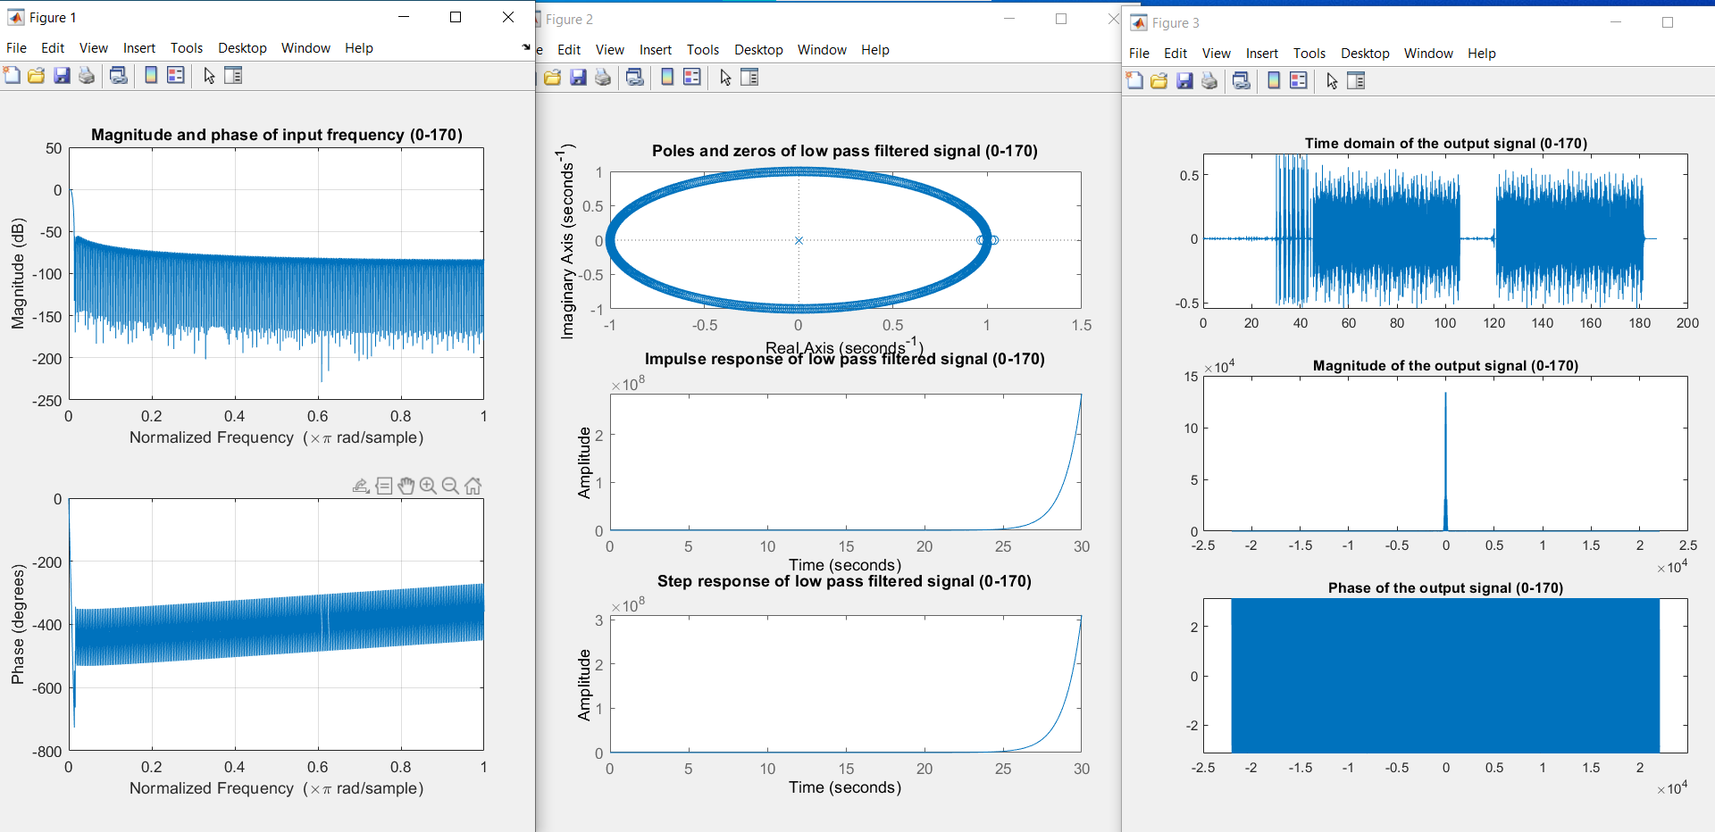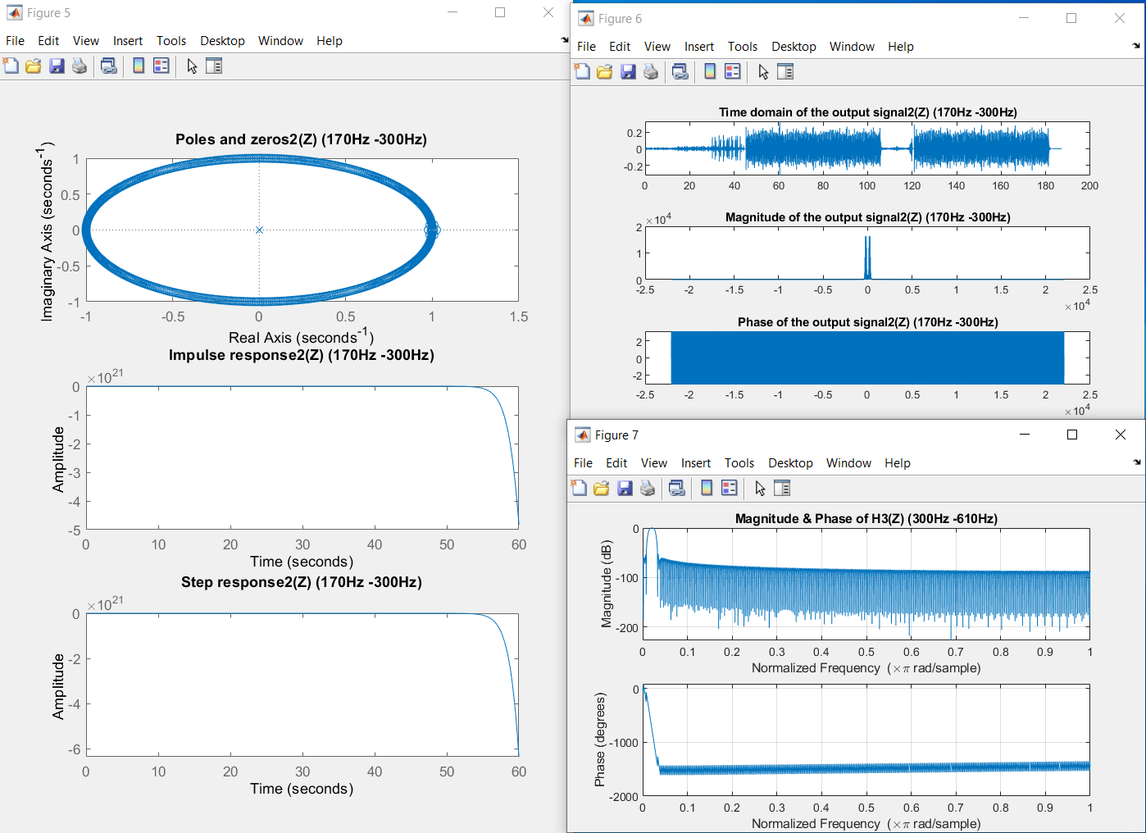**4-Analyze the input filter and the output :**

